**Convex Lenses Refraction Lab Report**

**Purpose:** Find the different refraction image of convex lenses.

**Hypothesis:** The convex lenses will refraction the image that always the real and inverted.

**Materials:** [tapeline](C:/Users/13256/AppData/Local/youdao/dict/Application/8.9.6.0/resultui/html/index.html" \l "/javascript:;), Convex Lens, candle, blank paper, water bottom.

**Procedure:**

**Part 1:**

1. Try to find the focal point use outside sun.
2. If not have sun, use the eyes to see the convex lens with no image.
3. Measure the length, and record the focal length.

**Part 2:**

1. Put the lens on the water bottle, and make the candle, the lens and the blank paper into a line.
2. Use the tape line measure the distance.
3. Measure the object distance at beyond 2f, at 2f, between 2f and f, at f , between f and lens.
4. Obverse and measure the image data, like image height and distance.
5. Record the data at the table.

**Data:**

**Focal length =40cm**

|  |  |  |  |  |  |
| --- | --- | --- | --- | --- | --- |
| **Object distance** | **Beyond 2f(cm)** | **At 2f (cm)** | **Between 2f and f(cm)** | **At f(cm)** | **Between f and convex lens(cm)** |
| **do** | 85 | 80 | 55 | 40 | 30 |
| **di** | 29 | 36 | 40 | No image | 27 |
| **hi** | 2 | 3 | 6 | No image | 5 |
| **Type of image** | real | real | real | No image | virtual |
| **Orientation of image** | inverted | inverted | inverted | No image | upright |
| **ho** | 4 | 3 | 5 | No image | 5.5 |

**Analysis:**

1. Describe the image for each scenario in part 2.
2. In the first scenario, the object is beyond the double distance of focal length.

The image location is in front of the object. Since the image distance is smaller than the object distance. The image orientation is inverted. I observed it at the blank paper. The image size is smaller, because the image height is smaller than the object height. The image type is real, because the image can see on the blank paper.

1. In the [second](C:/Users/13256/AppData/Local/youdao/dict/Application/8.9.6.0/resultui/html/index.html" \l "/javascript:;) scenario, the object is at the double distance of focal length.

The image location is in front of the object. Since the image distance is smaller than the object distance. The image orientation is inverted. I observed it at the blank paper. The image size is the same, because the image height is the same as the object height. The image type is real, because the image can see on the blank paper.

1. In the third scenario, the object is between the focal length and twice the focal length.

The image location is in front of the object. Since the image distance is smaller than the object distance. The image orientation is inverted. I observed it at the blank paper. The image size is bigger, because the image height is bigger than the object height. The image type is real, because the image can see on the blank paper.

1. In the fourth scenario, the object is at focal length. There was no image at this distance.
2. In the fifth scenario, the object is between the focal length and the convex lens.

The image location is in front of the object. Since the image distance is smaller than the object distance. The image orientation is upright. Since I saw this image through the lens. The image size is smaller, because the image height is smaller than the object height. The image type is virtual, because the image can not see on the blank paper.

1. Draw a ray diagram of any scenario in part 2.

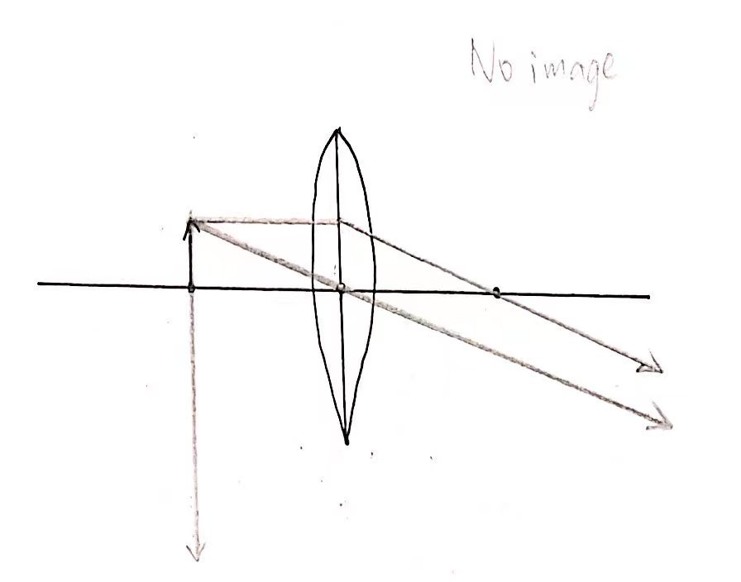

I draw a ray diagram is when the object at focal point, it doesn’t get image.

1. Calculate the average focal length from part 2, and compare it to part 1.

The equation that I used is .

Beyond 2f:  At 2f: 

between 2f and f:  between f and lens: 



The average focal length in part 2 are have big different at part 1 focal length. The average focal length in part 2 is almost twice as part 1 focal length.

**Conclusion:**

1. **Results:**

In the image refracted by convex lens, the image refracted by the object beyond the double focal length, at the double focal length, between the double focal length and the focal length are all inverted and real. The object has no image at focal point. The image that the object is between the focus point and the convex lens is virtual and upright.

1. **Comparison:**

Compared with my hypothesis, I'm only partially right, not completely right. Since in the image refracted by the convex lens, there is no image on the focus of the object, and the image refracted by the object between the focus point and the convex lens is virtual and upright.

1. **Error:**
2. The experiment exist inaccurate measurement. We just use tape line and eyes to measure, which will produce errors between real data and measure data. The resulting will inaccurate.
3. The candle flame is unstable during measurement. The candle flame sometimes higher, sometimes lower.
4. When measuring the image, I rely on my feelings to judge the image, and the paper I am holding will moves, making the measurement inaccurate.
5. **Improvement:**
6. Use a more accurate instrument to measure next time. It can use machine measurement instead of manual measurement. More accurate data can make more accurate result.
7. Try to keep the flame of the candle are stable.
8. Use machine measure instead of rely the feeling to measure.